**Bank Database**

**Question**

**(Week 03)**

**-** Branch (branch-name: String, branch-city: String, assets: real)

**-** BankAccount(accno: int, branch-name: String, balance: real)

**-** BankCustomer (customer-name: String, customer-street: String, customer-city: String) **-** Depositer(customer-name: String, accno: int)

**-** LOAN (loan-number: int, branch-name: String, amount: real)

- Create the above tables by properly specifying the primary keys and the foreign keys. - Enter at least five tuples for each relation.

- Display the branch name and assets from all branches in lakhs of rupees and rename the assets column to 'assets in lakhs'.

- Find all the customers who have at least two accounts at the same branch (ex. SBI_ResidencyRoad).

- Create a view which gives each branch the sum of the amount of all the loans at the branch.

**Schema Diagram**

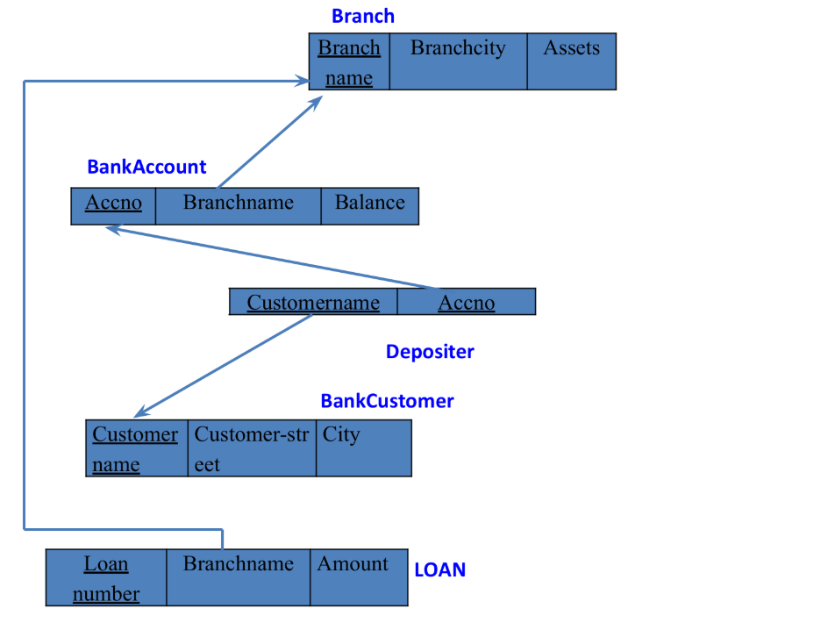

**Create database**

**create database** bank_402;

**use** bank_402;

**Create table**

**create table** Branch(

branchname varchar(20),

city varchar(20),

assets varchar(20),

**primary key**(branchname));

desc Branch;

**create table** Bankaccount(

accno int,

branchname varchar(20),

balance varchar(20),

**primary key** (accno),

**foreign key**(branchname) **references** Branch(branchname));

desc Bankaccount;

**create table** bankcustomer(

customername varchar(20),

customerstreet varchar(20),

customercity varchar(20),

**primary key**(customername));

desc bankcustomer;

**create table** depositer(

customername varchar(20),

accno int,

**primary key**(customername, accno),

**foreign key**(customername)**references** bankcustomer(customername),

**foreign key**(accno)**references** Bankaccount(accno));

desc depositer;

**create table** loan(

loannumber int,

branchname varchar(20),

amount int,

**primary key**(loannumber),

**foreign key**(branchname)**references** Branch(branchname));

desc loan;

**create table** Borrower(

customername varchar(20),

loannumber int,

**Primary key**(customername,loannumber),

**foreign key**(loannumber)**references** loan_402(loannumber),

**foreign key**(customername) **references** bankcustomer_402(customername));

Desc Borrower;

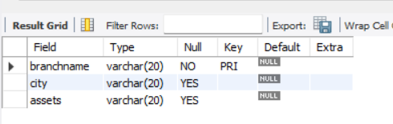

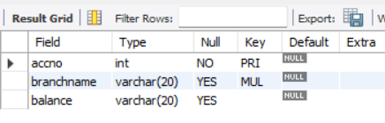

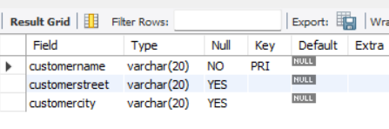

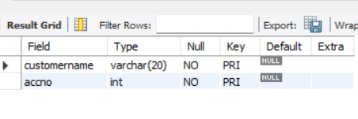

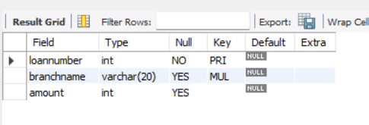

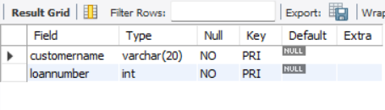

**Inserting the values**

insert into Branch values('SBI_Chamrajpete', 'Bangalore', 50000);

insert into Branch values('SBI_Residency_road', 'Bangalore',10000);

insert into Branch values('SBI_Shivaji_road', 'Bombay', 20000);

insert into Branch values('SBI_Parliament_road','Delhi', 10000);

insert into Branch values('SBI_Jantarmantar', 'Delhi',20000);

insert into Branch values('SBI_Mantrimarg','Delhi',150000);

select * from Branch;

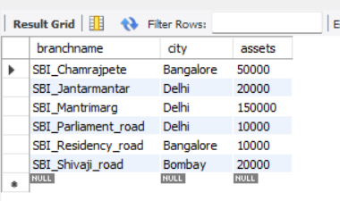

insert into Bankaccount values(1, 'SBI_Chamrajpete',2000);

insert into Bankaccount values(2,'SBI_Residency_road', 5000);

insert into Bankaccount values(3,'SBI_Shivaji_road', 6000);

insert into Bankaccount values(4, 'SBI_Parliament_road', 9000);

insert into Bankaccount values(5, 'SBI_Jantarmantar', 8000);

insert into Bankaccount values(6, 'SBI_Shivaji_road', 4000);

insert into Bankaccount values(8, 'SBI_Residency_road', 4000);

insert into Bankaccount values(9, 'SBI_Parliament_road', 3000);

insert into Bankaccount values(10, 'SBI_Residency_road', 5000);

insert into Bankaccount values(11, 'SBI_Jantarmantar', 2000);

insert into Bankaccount values(12, 'SBI_Mantrimarg',2000);

select * from Bankaccount;

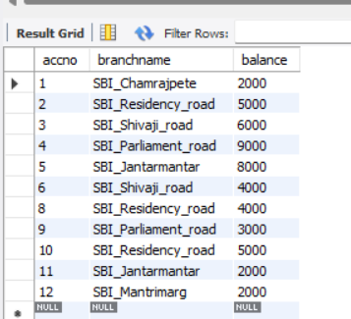

insert into bankcustomer values('Avinash','Bulltemple_road','Bangalore');

insert into bankcustomer values('Dinesh', 'Bannerghatta_road','Bangalore');

insert into bankcustomer values('Mohan', 'National_college','Bangalore');

insert into bankcustomer values('Nikhil', 'Akbar_road', 'Delhi');

insert into bankcustomer values('Ravi', 'Prithviraj_road', 'Delhi');

select * from bankcustomer;

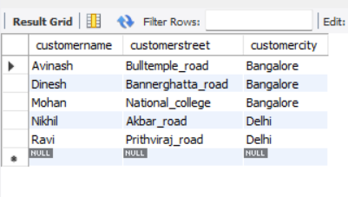

insert into depositer values('Avinash' , 1);

insert into depositer values('Dinesh',2);

insert into depositer values('Nikhil',4);

insert into depositer values('Ravi', 5);

insert into depositer values('Avinash',8);

insert into depositer values('Nikhil', 9);

insert into depositer values('Dinesh',10);

insert into depositer values('Nikhil',11);

insert into depositer values('Nikhil',12);

select * from depositer;

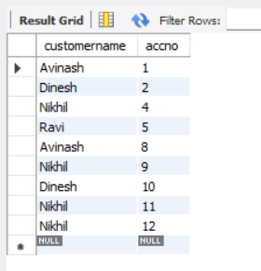

insert into loan values(1, 'SBI_Chamrajpete',1000);

insert into loan values(2, 'SBI_Residency_road', 2000);

insert into loan values(3, 'SBI_Shivaji_road', 3000);

insert into loan values(4, 'SBI_Parliament_road', 4000);

insert into loan values(5, 'SBI_Jantarmantar', 5000);

select * from loan;

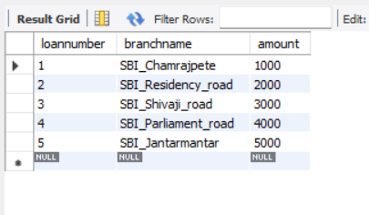

insert into Borrower values('Avinash',1);

insert into Borrower values('Dinesh',2);

insert into Borrower values('Mohan',3);

insert into Borrower values('Nikhil',4);

insert into Borrower values('Ravi',5);

Select * from Borrower;

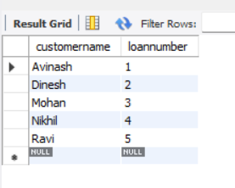

**Queries**

**● Display the branch name and assets from all branches and rename the assets column to 'assets in lakhs'.**

**alter table** Branch **rename column** assets **to** assets_in_lks;

**select** branchname, assets_in_lks **from** Branch;

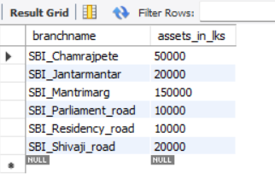

**● Find all the customers who have at least two accounts at the same branch (ex.SBI_ResidencyRoad).**

**select** d.customername **from** depositer d, Bankaccount b **where**

b.branchname=**'ResideRoad' and** d.accno=b.accno **group by** d.customername **having count**(d.accno)>=2;

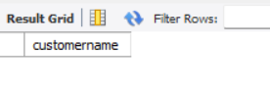

**● Create a view which gives each branch the sum of the amount of all the loans at the branch.**

**create** view br as select branchname, **sum**(amount) from loan

group by branchname;

select * from br;

